Dear all,

This week, our lab problem is on Fourier series.

To find a Fourier series expansion of a periodic function satisfying Dirichlet's condition, we have

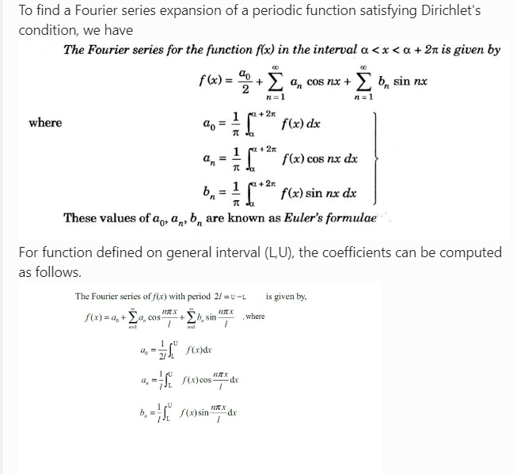

Using the last formula, herewith I am giving the Matlab code below:

syms x

f=input('Enter the function in terms of x:')

L=input('Enter the lower limit of the domain')

U=input('Enter the upper limit of the domain') % (L,U)

L1=(U-L)/2;

disp('Enter value of N between 1 and 7')

N=input('Enter the number of terms N')

a_0=vpa((2/(U-L))*int(f,x,L,U),4); %

F_s=a_0/2;

for n=1:1:N

a(n)=vpa((2/(U-L))*int(f*cos((n*pi*x)/L1),x,L,U),4); %2/(U-L)=1/L1

b(n)=vpa((2/(U-L))*int(f*sin((n*pi*x)/L1),x,L,U),4);

F_s=F_s+a(n)*cos((n*pi*x)/L1)+b(n)*sin((n*pi*x)/L1) % F_s= a0/2+a1+b1 ; 2nd iteration: F_s= a0+a1+b1+a2+b2

subplot(N,1,n)

plot1=ezplot(f,[L,U]);

set(plot1,'color','r')

hold on

ezplot(F_s,[L,U])

end

PLease do the following assignment problem attached herewith. Please let me know if you have any difficulties whiling computing. If you complete this assignment by yourselves and submit. If all of you submit the assignment by tomorrow night 12am. We may cancel Saturday's class. The attendance will be given based on your submission. ADDE-LAB-L13-L14-Winter-Sem-2020-21